Information Technology Institute (ITI) | Workforce Development & Continuing Education (WDCE)
ITI 490 – Virtual Office Management with Microsoft 365 Instructor: Carl Burnett Email: carl.burnett@montgomerycollege.edu

10 Sessions (30 Hours)

Course Syllabus

Attendance Policy:
80% attendance is REQUIRED to receive a Certificate of Completion; you must attend at least 8 sessions to be eligible. Your certificate will be sent to your Montgomery College email address.
Course Description: Acquire a comprehensive view of Microsoft 365 (formerly Office 365) to take advantage of its powerful business tools and maximize your productivity. Fill in the missing gap between the MS apps you already know (or haven’t seen in a while) and those you do not. You will learn how to use the power of the Cloud to collaborate and share with others from anywhere, at any time. You will learn to share and collaborate on OneDrive, Teams, and other MS 365 apps.

Course Objectives:
- Gain knowledge of the services offered in Microsoft 365
- Develop a comprehensive understanding of these services and how they work together
- Learn how to create and share files within the main services
- Learn how to collaborate on files and tasks in real-time

Pre-requisites:
- File Management skills
- Skills in basic navigation of the Windows Operating System
- Keyboarding and Mouse skills

TEXTBOOKS: There are no required textbooks for this course

Required Course Materials:
- There are no required course materials; however, a FLASH DRIVE is recommended to save your files (though we will be learning how to do this via the cloud)

Session Outline:
- Session 1: Course Intro/Overview, File Management, OneDrive
- Session 2: Word I
- Session 3: Word II
- Session 4: Excel I
- Session 5: Excel II
- Session 6: PowerPoint I
- Session 7: PowerPoint II
- Session 8: Outlook I
- Session 9: Outlook II SharePoint
- Session 10: MS Teams, SharePoint; Review, Other MS 355 Apps / Evaluations
Inclement Weather & MC Alerts
Operational Status (Closures & Delays):
https://www.montgomerycollege.edu/offices/public-safety-health-emergency- management/emergency-management/closures-and-delays.html

Sign Up For MC Alerts: https://www.montgomerycollege.edu/offices/public- safety-health-emergency-management/emergency-management/mc-alert.html
Before Our First Class Please Complete the Following:

- Claim your MyMC account
- Set up 2FA (Two-Factor Authentication)

Sign in to your Montgomery College e-mail
- Download/Install Microsoft Office 365

You should have received a letter advising you of your Montgomery College Student Identification Number (M Number) and your Username (MyMC ID)

- Claim your MyMC Account &
➔ Go to http://mymc.montgomerycollege.edu and follow the instructions on the ‘Claim your MyMC Account’ PDF attached to the welcome email from your instructor

Set up 2FA (Two-Factor Authentication)

➔ Download the 2FA Guide -

Access your Montgomery College Email Account

➔ Sign in to your MyMC Account.
Access your email account below:
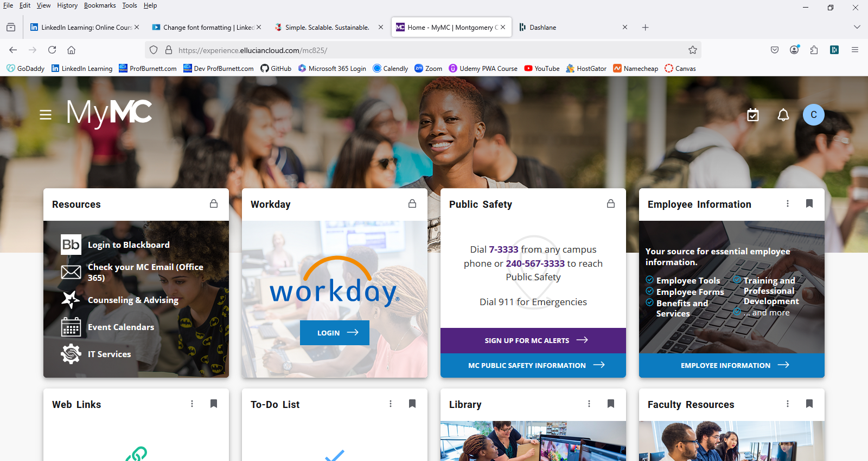

Download and install Microsoft Office 365

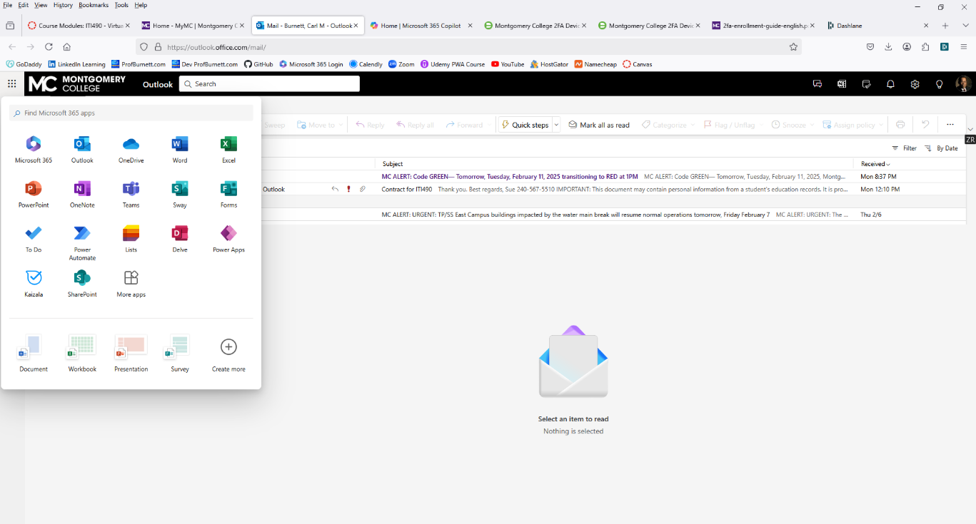
➔ This will install the applications we will be using – Word, Excel, & PowerPoint – on to your personal desktop or laptop computer.

